EXPERIENCE

**AKB Software:** **06/2022 – Present**

**Position**: Full Stack Developer

* **ChungVui** - chungvui.net
  + **Project Description:** Platform for creating and sharing event template online.
  + **Technology:**  MongoDB, NodeJS, ReactJS, TailwindCSS,..
  + **Responsibilities:**
* Share knowledge and build the core architecture of the project.
* Discussion and problem solving add useful features.
* Design UI/UX, database schema and implement the solution.
* Develop and fix bug based on requirements.
* Building a system to send emails.

SUMMARY

I'm a web developer with 1.5 years of experience in NodeJS technologies, with knowledge of Object-Oriented Analysis and Design, and Database Design.

Persistent in self-studying and learning new technologies, self-motivated, hard-working, responsible, and reliable, working effectively both independently and as a part of the team.

TECHNICAL SKILL

|  |  |
| --- | --- |
| * **Programming Language**: * JavaScript & TypeSript * **Frameworks/ Flatforms**: * NodeJS, ExpressJS, WebAPI, GraphQL * ReactJS, TailwindCSS, MaterialUI,   Bootstrap   * **Database Management Systems** * MS SQL Server, MongoDB | * **Foreign Language**: English (Basic - 500 Toeic) * **Soft Skills**:   - Teamwork  - Time Management  - Quality Check  - Flexibility in work |

* **Others**
* Understanding of OOP methodogies.
* Experience with CI, CD of GitLab, SVN.
* Experience with Agile and Scrum development process.
* Logical thinking.

EDUCATION

**Le Quy Don Technical University - MTA** (Ha Noi) **2017 - 2022**

* Software Engineering
* CPA: 2.9

**NGUYEN TU TINH**

**Phone:** +84 (03)67 005 758

**Birthday:** 19/04/1999

**Email:** [tutinh.nt@gmail.com](mailto:tutinh.nt@gmail.com)

**Address**: Chua Lang, Dong Da, Ha Noi

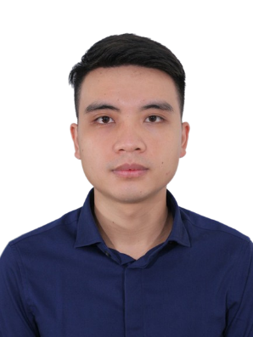

PASTIMES AND ACTIVITIES

* In my free time, I like exercise and go experience things, finding new technologies, and working on personal projects.
* **NS2HN**:
  + **Project name:** NS2HN - Asset Maintenance Management System
  + **Technology:**  GraphQL, NodeJS, ReactJS, Material UI, Bootstrap...
  + **Responsibilities:**
* Discussion and problem solving add useful features.
* Pariticipate developing and mainting based on requirements.

**Antbot Vietnam:**  **04/2021 – 03/2022**

**Position**: Fresher Developer

**VNMAC**:

* **Project Description:** Management system to overcome the landmine situation in Vietnam.
* **Technology:** Java Spring MVC, Jquery, Bootstrap,...
* **Responsibilities:**
* Design database schema and implement back-end services
* Develop and fix bug based on requirements